Wiseman Innovation UI Standards

WISEMAN INNOVATIONS
2340 East Trinity Mills Road Suite 250 Carrollton, TX 75006, United States



Certificate
Privacy Information
This document is the sole property of Wiseman Innovations and cannot be used for any other official, business, and personal means. All Rights Reserved @ Wiseman Innovations.
Copyrights
Wiseman Innovations has intellectual property rights relating to the substance that is described in this document. No part of this document may be reproduced or published in any form or by any means, without the express written permission of Wiseman Innovations. The User may view the content of this document on screen, print out copies or store electronically for personal use only as authorized and signed-on by Wiseman Innovations.
Acknowledgement
Data/ records shown in the document are used for illustrative purposes only and have no relation to original data; this data has been used solely to explain system functionality. Please enter original data in the system when using the system.

Document Change History
Document Version | Date | Developed By | Reviewer | Description of Changes
V – 1.3 | 1st April 2018 | Ahsan Khurshid | Ahsan Khurshid | Implementation of changes suggested by team
V – 1.5 | 2nd July 2018 | Shahzeb Babar | Ahsan Khurshid | Adjustments done according to the provided template

Typography:
Headings:
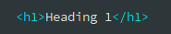
h1. Heading 1
Heading 1: Font Size: 36px | Font-weight: 400 | Font-Color: #333333 | Font-Family: Open Sans

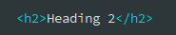
h2. Heading 2
Heading 2: Font Size: 30px | Font-weight: 300 | Font-Color: #333333 | Font-Family: Open Sans

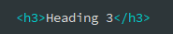
h3. Heading 3
Heading 3: Font Size: 24px | Font-weight: 300 | Font-Color: #333333 | Font-Family: Open Sans

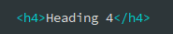
h4. Heading 4
Heading 4: Font Size: 18px | Font-weight: 300 | Font-Color: #333333 | Font-Family: Open Sans

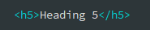
h5. Heading 5
Heading 5: Font Size: 14px | Font-weight: 600 | Font-Color: #333333 | Font-Family: Open Sans
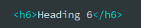

h6. Heading 6
Heading 6: Font Size: 12px | Font-weight: 600 | Font-Color: #333333 | Font-Family: Open Sans

Body:
Text Body Lead 1
Body Lead: Font Size: 24px | Font-weight: 300 | Font-Color: #333333 | Font-Family: Open Sans

HTML:
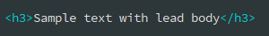

Text Body Lead 2
Body Lead: Font Size: 21px | Font-weight: 300 | Font-Color: #333333 | Font-Family: Open Sans

HTML:

Text Body
Body: Font Size: 14px | Font-weight: 400 | Font-Color: #333333 | Font-Family: Open Sans

HTML:
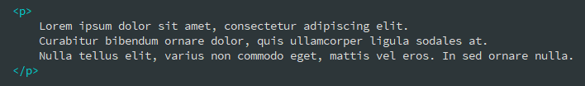

Unordered Lists:
Unordered Lists: Font Size: 14px | Font-weight: 400 | Font-Color: #333333 | Font-Family: Open Sans

- Lorem ipsum dolor sit amet
- Nulla volutpat aliquam velit
  - Phasellus iaculis neque
  - Purus sodales ultricies
- Aenean sit amet erat nunc
- Eget porttitor lorem

HTML:
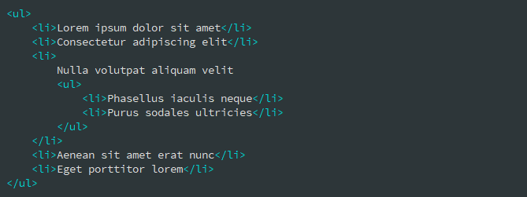

Ordered Lists:
Ordered Lists: Font Size: 14px | Font-weight: 400 | Font-Color: #333333 | Font-Family: Open Sans
- Lorem ipsum dolor sit amet
- Facilisis in pretium nisl aliquet
- Nulla volutpat aliquam velit

HTML:
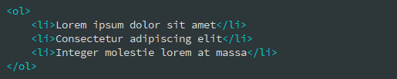

Description Lists:
Heading: Font Size: 14px | Font-weight: 700 | Font-Color: #333333 | Font-Family: Open Sans
Body: Font Size: 14px | Font-weight: 400 | Font-Color: #333333 | Font-Family: Open Sans

Description list Item 1
A description list is perfect for defining terms.

Description list Item 2
A description list is perfect for defining terms. Vestibulum id ligula porta felis euismod semper eget lacinia odio sem nec elit.
HTML:
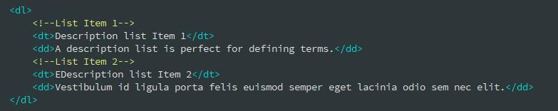
Text States:
Body: Font Size: 14px | Font-weight: 400 | Font-Family: Open Sans

Muted text here

Primary text here
Success text here
Danger text here

General Components:

Alerts:
Body: Font Size: 14px | Font-weight: 400 | Font-Family: Open Sans

Default Alerts:
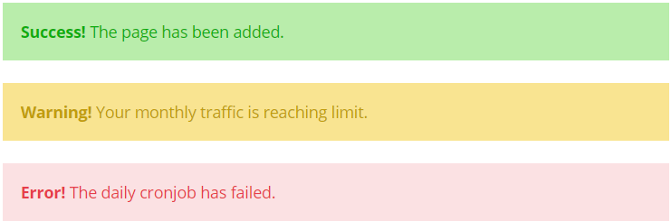

HTML: | CSS Class(es):
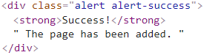 | alert-success  alert-warning  alert-danger

Dismissible Alerts (Same color variations as above with close icon):

HTML:
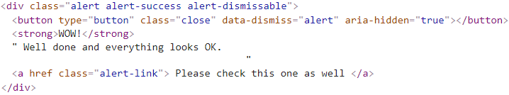

Button Styles:
Styles: Font-weight: 400 | Font-Family: Open Sans | Font-Size: 14px

Solid Buttons:
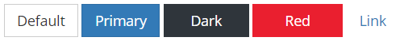

HTML:
CSS:
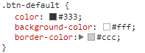 | 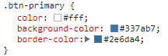
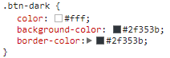 | 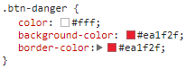
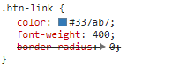

Outlined Buttons (Custom):

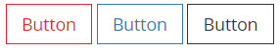
HTML:
CSS:
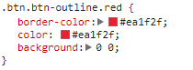 | 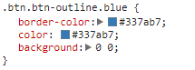
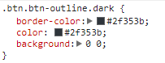

Code Commenting:
HTML Comments:
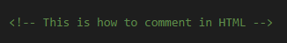
JavaScript Comments:
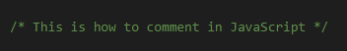

Window Dialog/Modals/Popups: Preview
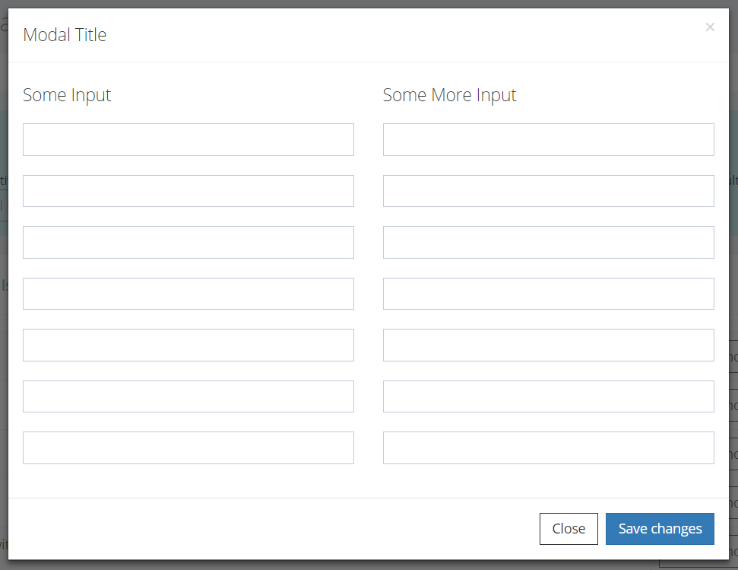
HTML:
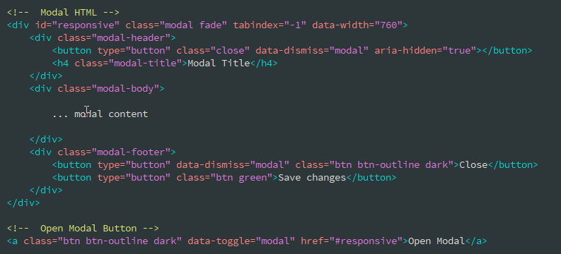
Form: Preview

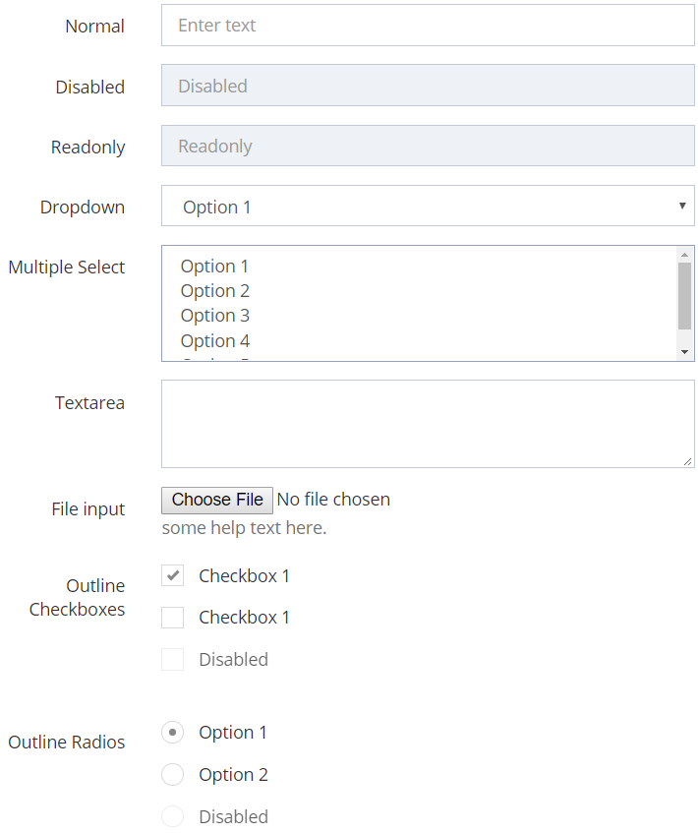

Preview
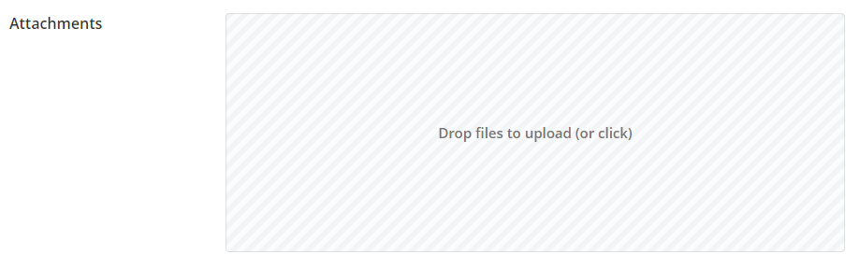
Normal Text Field with Label:

HTML:
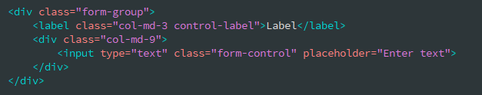
Disabled Text Field with Label:

HTML:
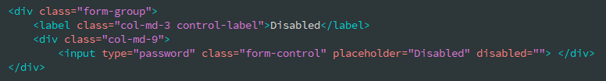

Readonly Text Field with Label:

HTML:
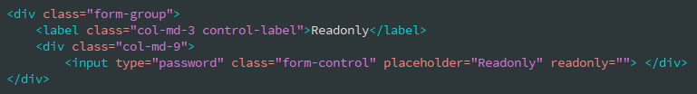

Dropdown with Label:

HTML:
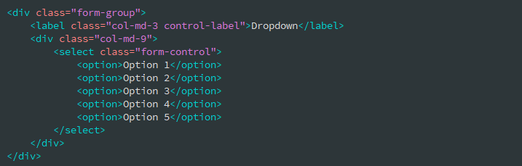
Multiple Select with Label:
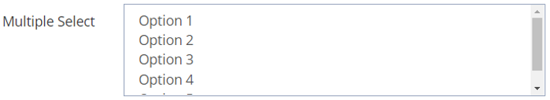

HTML:
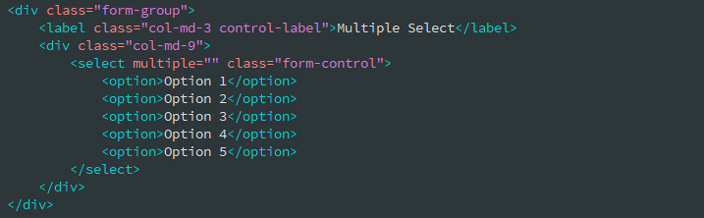

Textarea Field with Label:
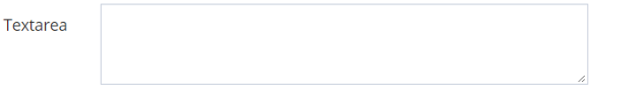

HTML:
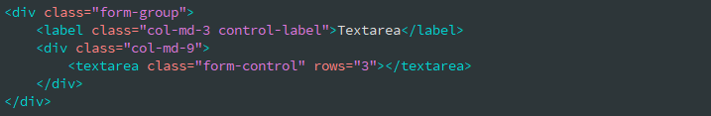

File Input Field with Label:

HTML:
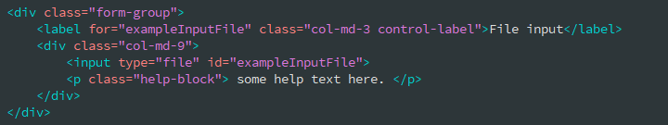

File Input Drop Zone with Label:
HTML:
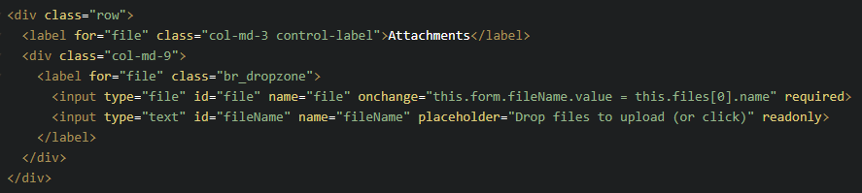
Checkboxes with Label:


HTML:

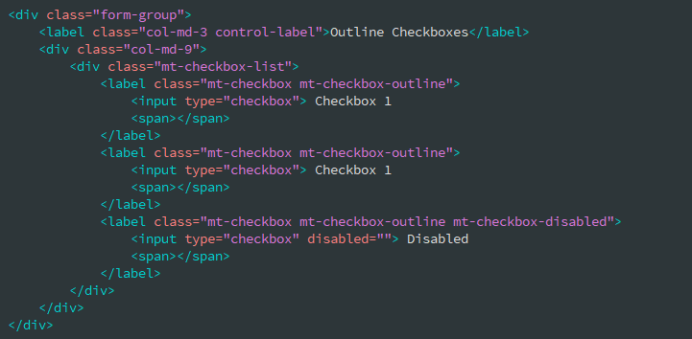
Radio Buttons with Label:
HTML:
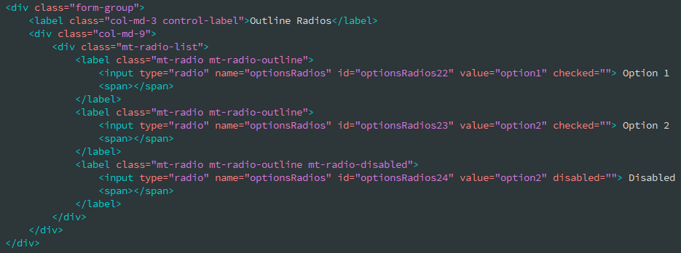

Form Validations:
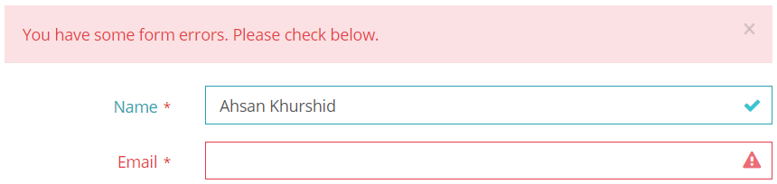
HTML (Input Fields):
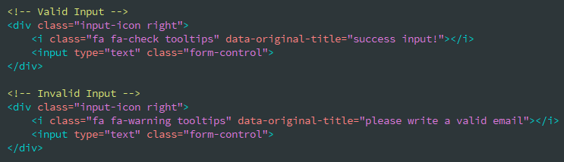

HTML (Dismissable Alerts):
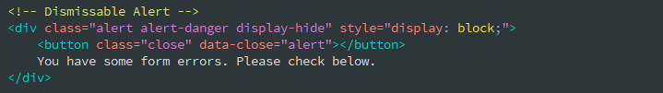

Accordions:
Styles: Font-Family: Open Sans
Title-Font-weight: 300 | Title-Font-Size: 16px | Desc. Font-Weight: 400 | Desc. Font Size: 13px

Example 1:
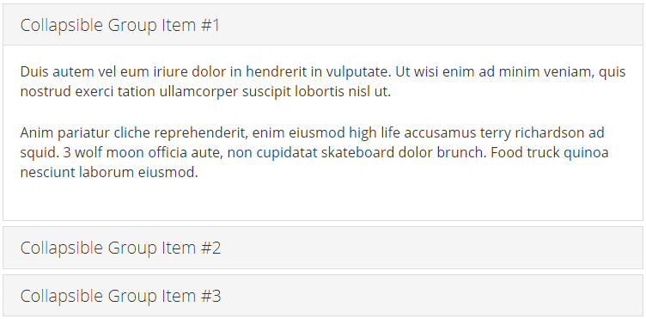

Example 2:
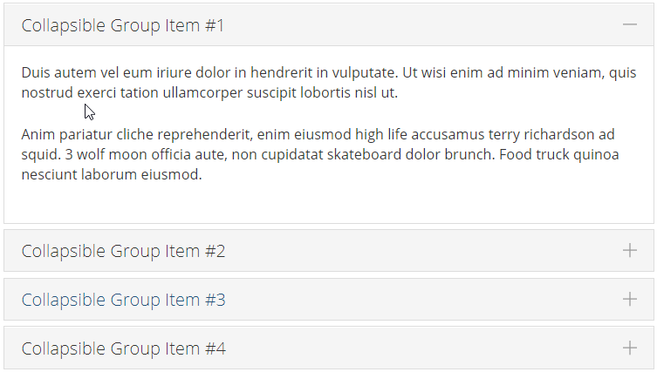

HTML:
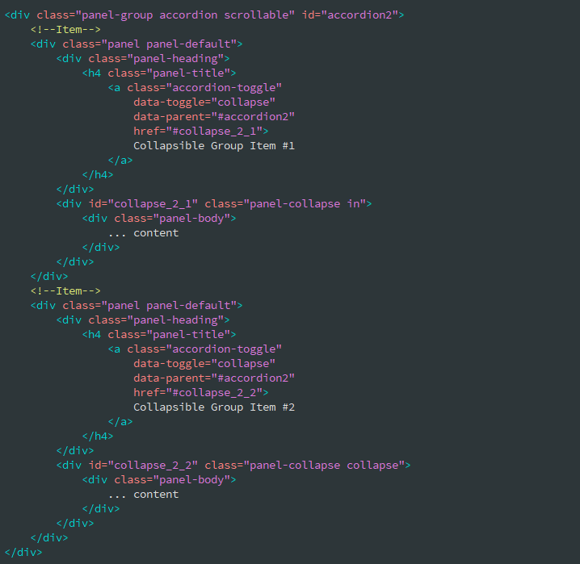

Add class “accordion-toggle-styled” for plus, minus icons as given in example 2 above:
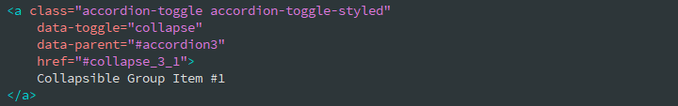
Tabs:
Styles: Font-weight: 400 | Font-Family: Open Sans | Font-Size: 14px

Default Tabs:
HTML:
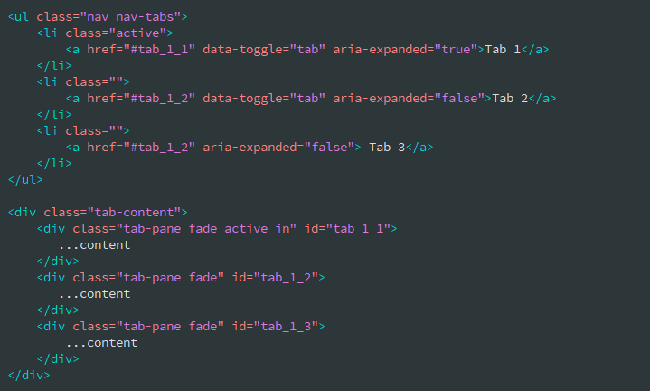

Large Number of Tabs Using Dropdown Menu:
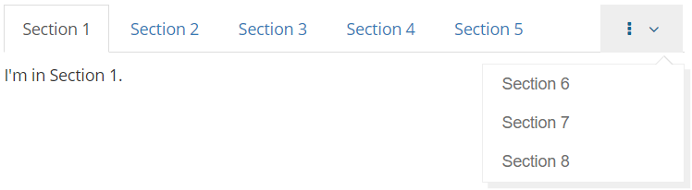

Notes: Add following code before Tab 1 <li> item to achieve above result. Also add “tab-pane” in tab-content section for each newly added list items.

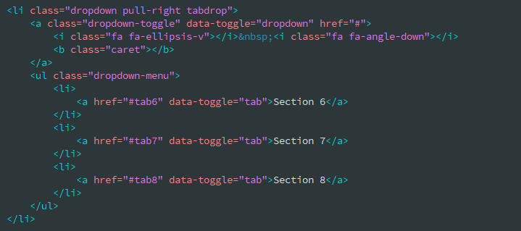

Left Styled Tabs:
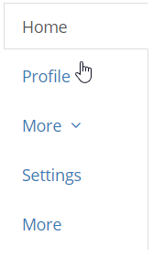 | Notes: To achive this add bootstrap row with two cloumns having following code:  Left Column: Add class “tabs-left” to make tabs left styled.  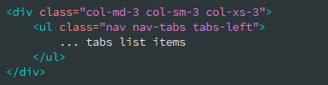  Right Column:  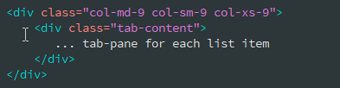

Right Styled Tabs:
Notes: To achive this add bootstrap row with two cloumns having following code:  Left Column: Add class “tabs-right” to make tabs right styled.  Rest code is same as above for left styled tabs. | 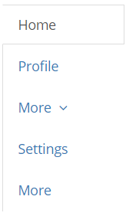
Reports:

Tables:

Data Tables (Managed with Buttons, Pagination, Sorting)

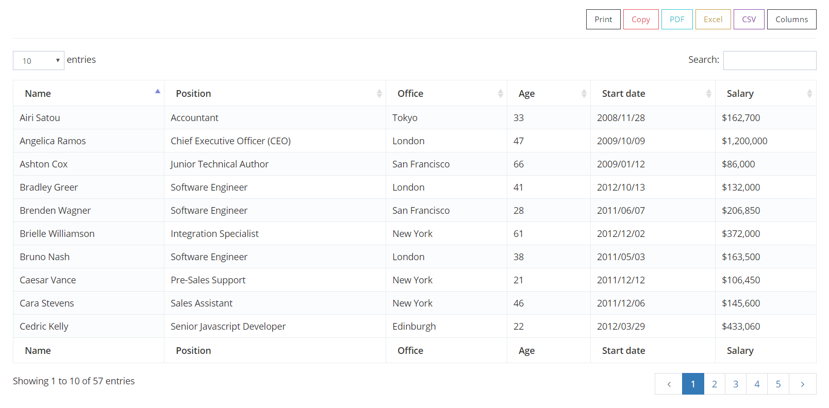
Data Tables (With large number of columns)
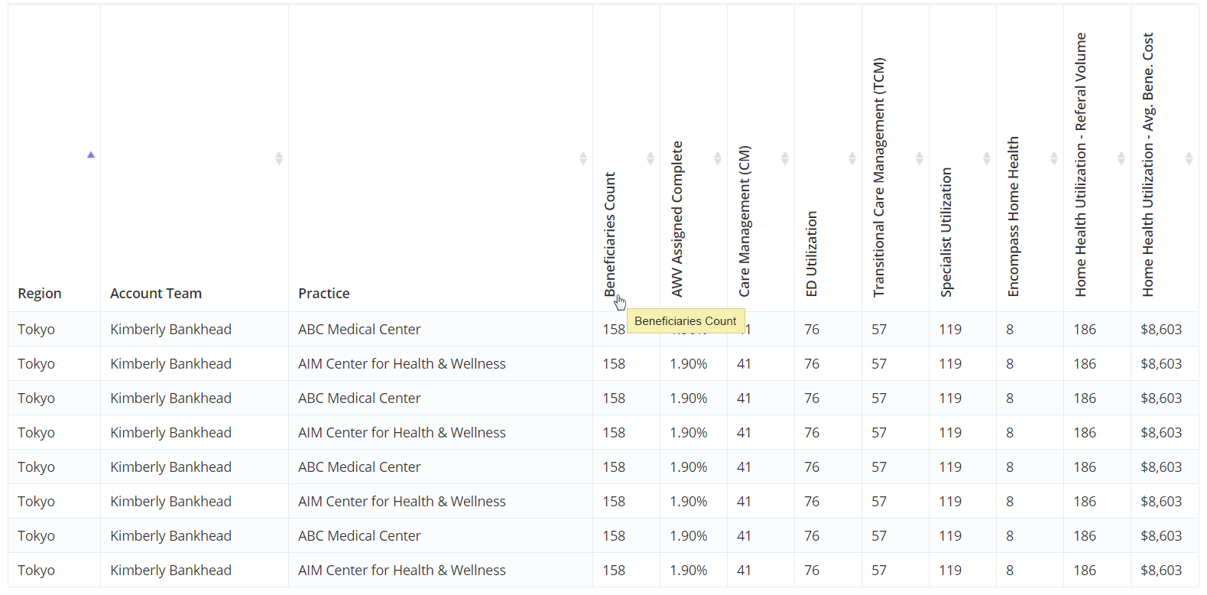
See code examples below:
HTML:
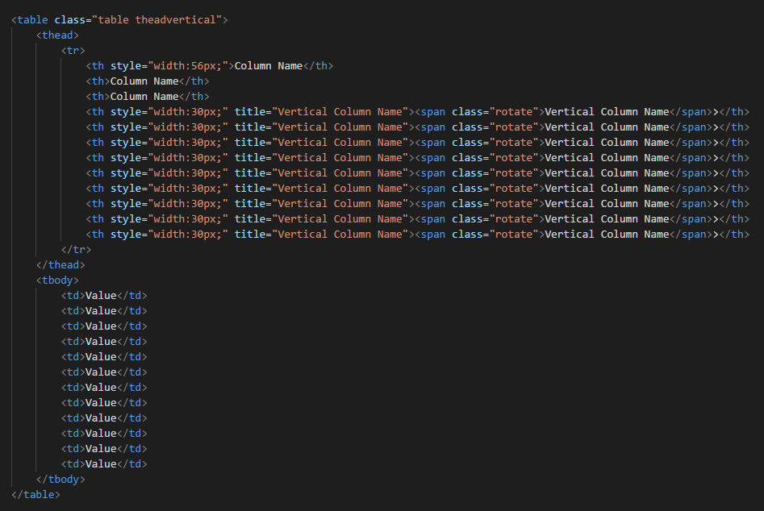
CSS:
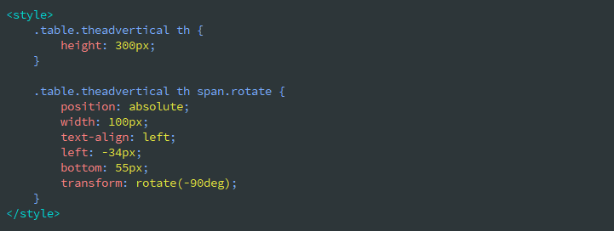
Data Tables (With Child rows)

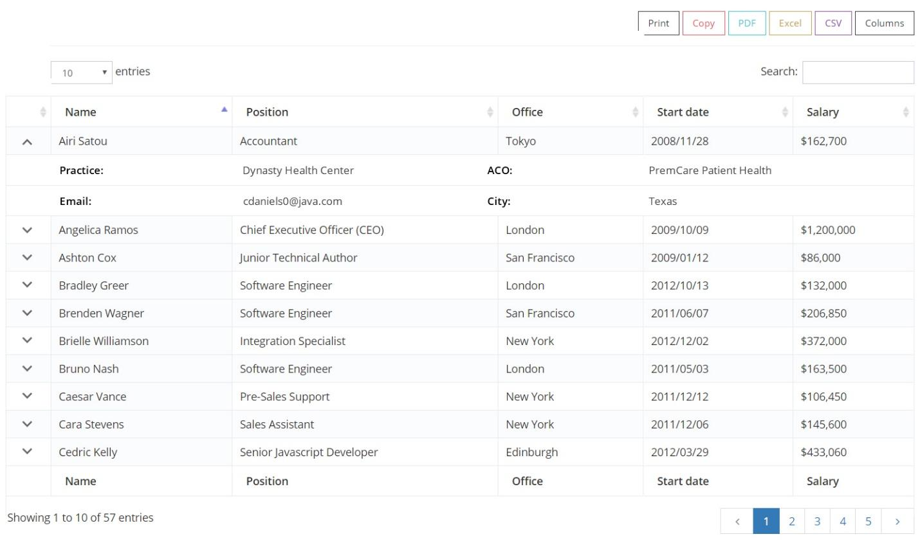

Pagination Styles:
Styles: Font-weight: 300 | Font-Family: Open Sans | Other Styles: Default Bootstrap Styling
Medium: Font Size: 14px
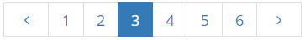

HTML:
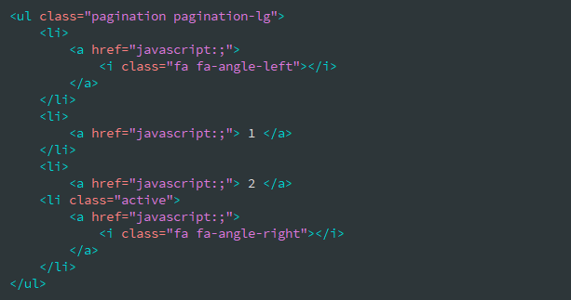

Small: Font Size: 12px
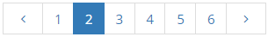

Pagination with First and Last buttons:


JS Options:
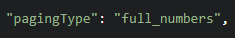

HTML:


